**Running simulations on the KKI Penguin Cluster**

1. Connect to FileZilla

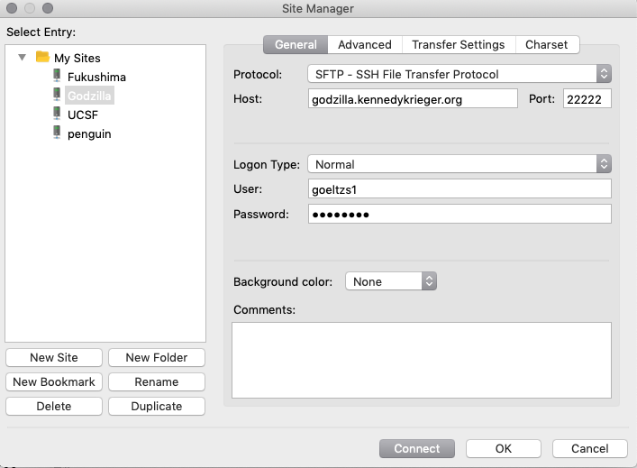

1. In FileZilla, copy your MATLAB simulation code file (for example sim_PRESS_Siemens.m) to a folder in your Godzilla home directory.

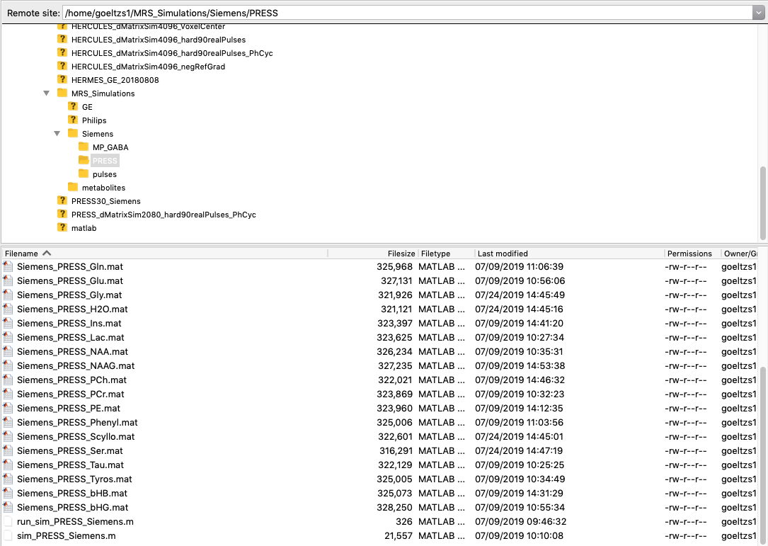

* 1. Make sure you have a copy of FID-A somewhere in your Godzilla home directory, and that this path is added to the MATLAB path (‘addpath(genpath())’) in your simulation code file.
  2. Make sure you have a folder ‘metabolites’ containing the FID-A spin system definitions somewhere in your Godzilla home directory (I’ve simply copied the FID-A/simulations/metabolites folder to /home/goeltzs1/MRS_Simulations/metabolites). This folder needs to be in the first line in qsub_run_density_matrix_sim.sh.
  3. Make sure that you have all required pulse waveform pta files in a folder (ideally vendor specific). This folder needs to be added to the MATLAB path in qsub_sim_metab.sh

1. In FileZilla, copy qsub_sim_metab.sh and run_density_matrix_sim.sh to any location in your home directory (for example /home/goeltzs1). This only needs to be done once – you can edit them for each job submission – but if you like, you can of course keep copies of them separately in each job folder.
2. Open a MacOS Terminal and connect to Godzilla (enter password)

ssh -Y -p 22222 shui5@godzilla.kennedykrieger.org

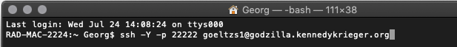

1. Connect to Penguin:

ssh penguin.kennedykrieger.org

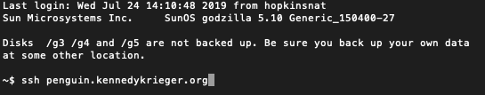

1. Use the commands “nano run_density_matrix_sim.sh*” or “*nano qsub_sim_metab.sh” in the Penguin terminal to edit contents:

In run_density_matrix_sim.sh, only change the location of the metabolite list (see Step 2b):

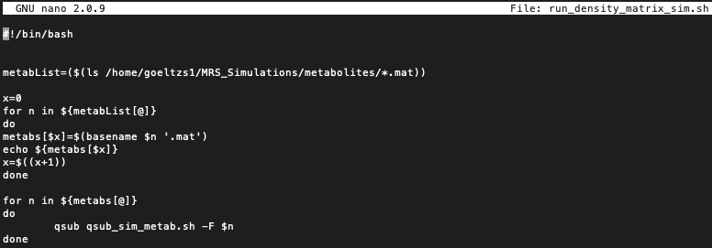

In qsub_sim_metab.sh, change:

* The working directory (-d)
* The job name (-N)
* The report file (optional, -o)
* The working directory in the command on the last line
* The pulse file directory in the command on the last line
* The name of the simulation code m file on the last line

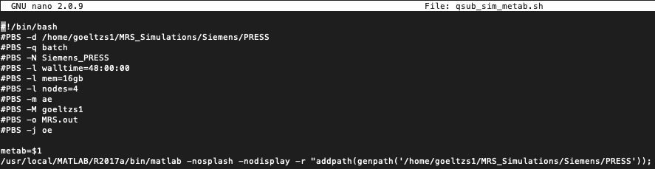

Hit Ctrl-X to exit, hit Y to save.

1. To submit the job, run “bash run_density_matrix_sim.sh” on the Penguin prompt.

Help on the Penguin job submission system (“Torque”) is on Godzilla.kennedykrieger.org under Penguin Compute Cluster – Torque on the Cluster

Most important commands:

qstat – gives overview of the status of the jobs

qdel XXX – deletes job number XXX